00000000000000000000000000000000000000000000000000000000000000000000000000000000000000000000000000000000000000000000000000

JC Rupe

Date: **January 18, 2017**

Version: **1.0.1.2**



**Project Eden:**

*Service Activity Creation Application*

**IT Project Management Office**

Document Revisions

|  |  |  |
| --- | --- | --- |
| Date | Version Number | Document Changes |
| 2016/11/28 | 1.0.0 JC | Document initial creation/completion. |
| 2017/01/12 | 1.0.1 JC | Edited a small amount of the wording. Section 1.1. |
| 2017/01/17 | 1.0.1.1 JC | Added document name to footer. |
| 2017/01/18 | 1.0.1.2 JC | Reworked this document. |
|  |  |  |
|  |  |  |
|  |  |  |
|  |  |  |
|  |  |  |
|  |  |  |

Contents

1 How to Access Service Activity Creation 3

1.1 Important Information 3

1.2 Navigate to Service Activity Creation Application 3

1.3 Page Layout and Features 4

1.3.1 Move Contract Type 4

1.3.2 Start Date 4

1.3.3 Refresh Moves 4

1.3.4 Create Service Activities 4

1.3.5 Error Message Panel 4

1.3.6 Page Navigation 5

1.4 Select the Move Contract Type 6

1.5 Create New Service Activities 6

1.6 Correct Move Errors 7

1.6.1 Reason Why You Can’t Create Service Activity for the Move 7

1.6.2 Correct the Move Record Error(s) 7

# How to Access Service Activity Creation

The Service Activity Creation tool displays all open Moves that, as yet, have no Service Activities. Using this tool it is quick and easy to create a Service Activity for a Move.

## Important Information

* **Selecting a record, not a link in the record:** Try to select a part of the record line that doesn’t contain a link. Remember, text displayed in blue is a link. If you click on the link, it will open that items information page. For example if you select the name of the Contact, the Contact information page in Eden will open. If this happens, you may have to navigate back to the previous page or close the window that opened when you selected the link.
* The preferred browser to use is Microsoft Explorer, although, Chrome and Firefox should also work.

## Navigate to Service Activity Creation Application

1. Navigate to the Service Activity Creation application.
   1. See your supervisor if you don’t have this link.
2. The “Service Activity Creation” application will open and display in a window.

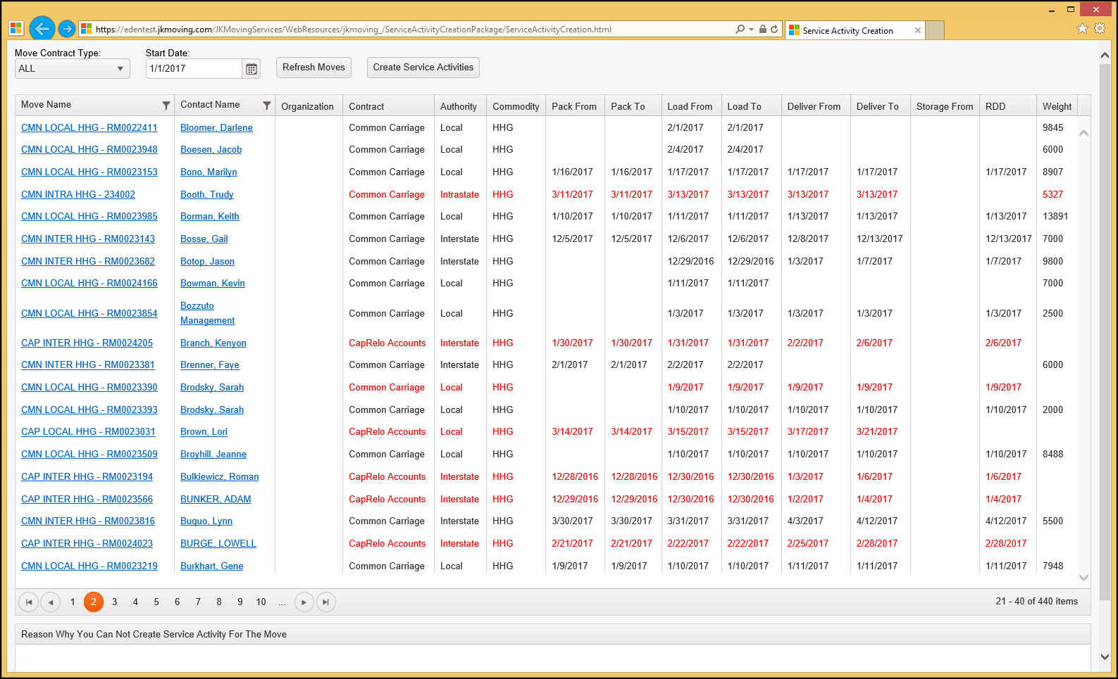

## Page Layout and Features

### Move Contract Type

You are able to restrict the displayed records to a specific Move Contract Type.

1. Dropdown menu options are:
   1. **All** – This is the default setting.
   2. **Common Carriage**
   3. **Military**
   4. **GSA**
   5. **State** **Department**
   6. **CapRelo** **Accounts**
   7. **National** **Accounts**

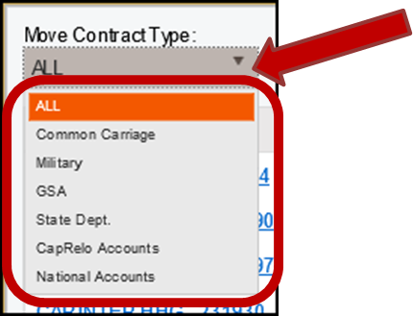

### Start Date

The “Start Date” will restrict the record display to only Moves with a Service that needs to be performed on or after the entered date.

### Refresh Moves

Selecting the “Refresh Moves” button will refresh the display of the Move records. 

### Create Service Activities

Selecting the “Create Service Activities” button will cause the appropriate Service Activities to be generated for the selected Move record. 

### Error Message Panel

The bottom panel of the page displays any errors in the selected Move that prevent the creation of Service Activities. This panel is titled “Reason Why You Can Not Create Se4rvice Activity For The Move”.

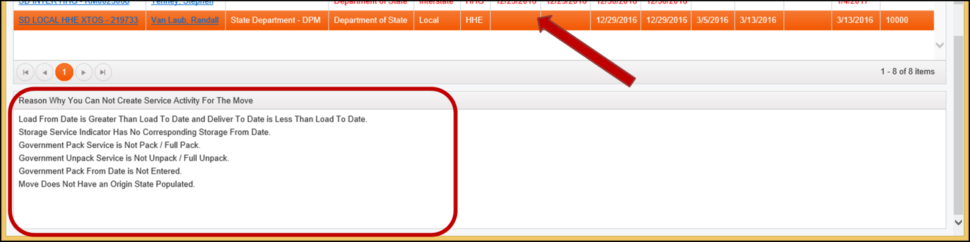

### Page Navigation

It’s easy to navigate through the Move record display pages.

* Page navigation buttons are located in the lower left of the window display.
* A maximum of 20 records are displayed on each page.
* The record number range is displayed in the lower right of the window display.

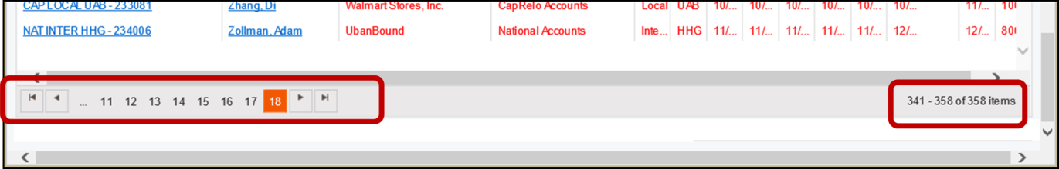

1. Locate the Page Navigation buttons, near the lower left of the window.
   1. The page numbers are displayed in increments of 10.
      1. Just select the desired page number.
   2.  This button displays the next and/or previous set of 10 pages.
   3.  This button navigates to the previous page.
   4.  This button navigates to the next page.
   5.  This button navigates to the first page.
   6.  This button navigates to the last page.
2. Locate the record number, of total records, are being displayed, near the lower right of the window.
   1. Displayed are the record count numbers and the total record count



## Select the Move Contract Type

You are able to display specific Move Contract Type records.

1. Select the down arrow on the right of the “Move Contract Type” field.
   1. The field is located in the upper left of the window.
2. A selection menu will display.
   1. Options are:
      1. **All** – This is the default setting.
      2. **Common Carriage**
      3. **Military**
      4. **GSA**
      5. **State** **Department**
      6. **CapRelo** **Accounts**
      7. **National** **Accounts**



## Create New Service Activities

Service Activities may also be created or started from within Eden, in the Move itself.

1. Select the desired Move record.
   1. Upon selection, the record will change color.

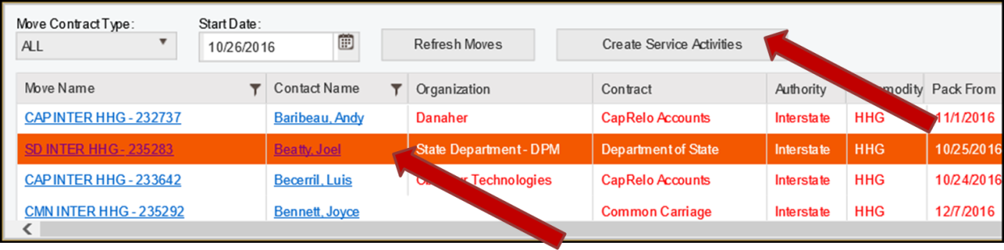

1. Select the “Create Service Activities” button.
2. The Move record will disappear from the Service Activity Creation window.
3. Appropriate Service Activities have been created for the Move.
4. If desired, navigate to Eden to perform any further work on the Move and Service Activities.
   1. See the “EDEN - Customer Service Reference Guide.docx” documentation.

## Correct Move Errors

### Reason Why You Can’t Create Service Activity for the Move

When a Move record has errors that prevent the creation of a Service Activity, the record fields (other than Move Name and Contact Name) display in Red. The “Create Service Activities” button will be deactivated.

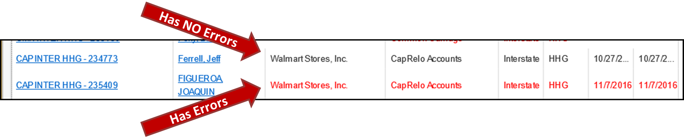

1. Select the Move record that contains errors.
2. Look in the lower left corner of the window.
   1. You may need to scroll down.
3. Listed there are the error reason(s).
   1. There may be more than one reason for the error.

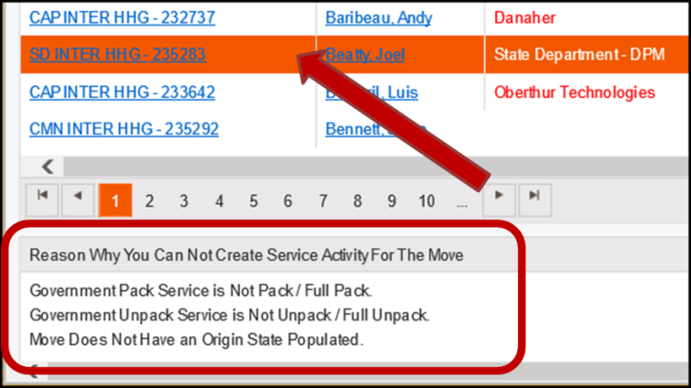

### Correct the Move Record Error(s)

1. Determine the reason(s) for the error(s).

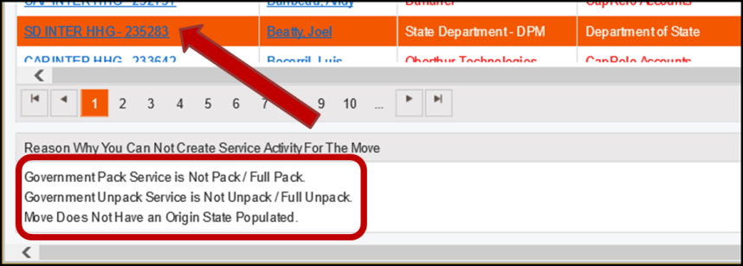

1. Navigate to Eden to edit the Move.
   1. Click on the Move Name.
2. Eden will open in a new tab and display the “Move: Information” window, for the selected Move.
3. Make all corrections for all the errors.
4. Return to the “Service Activity Creation” window.
5. Refresh the window.
   1. The refresh may be accomplished in multiple ways.
      1. Select the browser refresh button. 

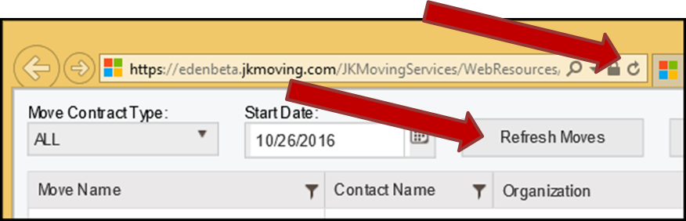

* + 1. Select the “Refresh Moves” button.



* + 1. Navigate to a different page within Service Activity Creation and then return to the desired page.

1. Locate the corrected Move.
   1. Note that the record fields (other than Move Name and Contact Name) now display in black, indicating that the Move has no errors.



1. Select the corrected Move record.
   1. Note that there are no errors listed in the “Reason Why You Can Not Create Service Activity For The Move” panel, located in the lower left corner.

